Maintenance Budget based on Replacement Asset value
By Joel Levitt
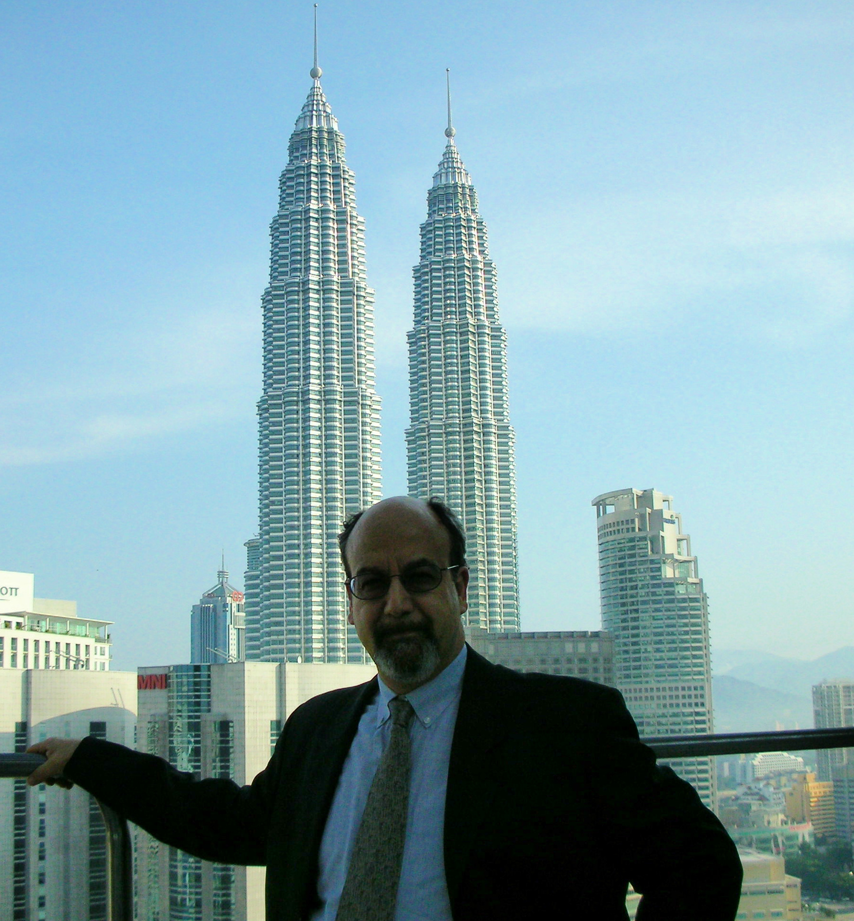
One of the quickest ways to determine the pattern in an organization is to see how much money is available for maintenance in relation to the size and use of the asset. Some organizations squeeze maintenance, others (fewer and fewer) over spend in the maintenance area. The idea behind these formulas is that the maintenance investment required by an asset is related to its size, replacement value and usage. Without this investment the asset will inevitably deteriorate.

Many organizations squeeze the maintenance department's budget and reduce the dollars for maintenance every year. Every reduction below the base need level that is not covered by increases in efficiency , productivity, or by maintenance improvements will result in deterioration. This formula includes all direct maintenance labor, materials and overhead. It does not include janitorial services. This quick estimate might be off by 30% and still will provide useful information.

There are only a few ways to deal with significant shortfalls of maintenance dollars. The most common way is to let the asset deteriorate. Walk around most major cities, an older steel mill, or most smaller scrap metal hauler operations and you can see the deterioration option at work. The other two strategies are ultra high productivity of the maintenance workers where they can do more maintenance per dollar then most departments. The last strategy is a department that has an effective maintenance improvement or RCM program running to reduce overall amount of maintenance needed by the equipment and facility.

Elements that determine the estimate of the maintenance budget:

1. Size of asset
2. Type of construction, materials & workmanship
3. Quality of design
4. Age of building, equipment, vehicle
5. History
6. How asset is used
7. Location
8. Knowledge and dedication of staff
9. Availability of spare parts and quality contractors
10. Type, knowledge, expectations of users
11. Laws, building codes, statutes that effect business
12. Taxes
13. Amount of change in your organization (or your user's organization)
14. Competition
15. Amount of deferred maintenance
16. Hours of use a day
17. Production level or speed of operation

The formula for maintenance budget estimate

((RCB * MR) + (RCSE * EMR)) * CR = MB

RCB = Replacement cost of building or facility. This number can be determined from the R. S. Means* costing information or experience. The basis includes all standard HVAC, plumbing and electrical equipment. Replacement costs can be obtained from square footage estimates.

MR = Maintenance ratio. This number is the percentage of the asset value which must be reinvested to ward off deterioration. The range for standard type buildings is 1% to 3% per year. The exact amount depends on the use of the building, part of the country and type of construction. Keep in mind a 2% MR would mean that the entire building would be replaced on a 50 year cycle.

RCSE = Replacement cost of production and mobile equipment. This would include production equipment, process boilers, mobile equipment, fleet trucks, etc. In factories, process plants and other equipment intensive applications the equipment factor far outweighs the cost of building maintenance.

EMR = Equipment maintenance factor is equivalent to the MR but for production equipment. The equipment maintenance factor for all but the most unusual equipment is 7% to 15% per year of replacement value. Note that service companies provide full labor and parts service contracts on electronic equipment for 12% of replacement cost (which includes profit).

If you have several big categories of assets then you might consider having different factors for the different classes. A paper mill might have the paper machine in one group and the delivery fleet in another. In the article "Another Way to Measure Costs" from all the way back in 1972 in Factory magazine the factor was calculated from 1% (labor intensive)-12%(capital intensive) range.

CR = Construction ratio is the ratio of time and materials spent doing renovation and new construction to the total time spent on all maintenance activity. It must be added to above. Construction or the installation and/or building of new equipment is not a maintenance function (not required to preserve the asset). It is frequently the responsibility of the maintenance department. This includes office construction, machine building, new installations, and truck body mounting.

MB = Maintenance budget with labor, materials, fringe benefits and overhead but without janitorial costs.
MB/Sq foot = maintenance costs per square foot of building or facility.
MB/Rev = Maintenance budget per revenue dollar
MB/Out = maintenance costs per unit output (such as linear foot of fabric, yards of refuse, patient-days, or ton-miles)

In some analysis of maintenance costs work both types of assets are lumped together in a replacement asset values or RAV. The two maintenance ratios are then also lumped together.

Shopping Center case study

Formula:((RCB * MR) + (RCSE * EMR)) * CR = MB

750,000 sq foot shopping center with a co-gen facility

RCB: Cost about $75/sq foot building value = $56,250,000

MR: based on location and construction = 2%

RCB * MR = $1,125,000

RCSE: Cost for co-gen facility = $2,600,000
EMR: based on similar facilities = 6%
RCSE * EMR = $156,000

CR: very small amount of construction
by maintenance dept (only 3%) = 1.03

(($56,250,000 * 2%) + ($2,600,000 * 6%)) * 1.03 = $1,319,430
(( RCB * MR) + ( RCSE * EMR)) * CR = MB

MB/Sq foot = Maintenance cost per square foot

$1,319,430/ 750,000 sq ft = $1.759/sq ft.

This number is relevant only in relation to the factors that impact the budget from the first page: type of construction, quality of design, age, history, location of facility, knowledge and dedication of your staff, availability of spare parts and quality contractors, type, knowledge, expectations and quality of tenants or users, building codes and statutes that effect business, taxes, amount of change in your organization (or your user's organization), competition, amount of deferred maintenance

Details can be derived from the general budget estimate
From the overall maintenance budget we can determine the detailed items such as labor, materials, and overhead. We apply historic percentages to the overall budget and find the detailed amounts and crewing.

100% budget = Labor % + Materials %
The labor % is traditionally in the range of 30% to 50%. Historical rule of thumb (from How to Manage Maintenance) is labor + fringes equal a- 2/3 of total maintenance costs.

$1,319,430 = 50% Labor + 50% materials
$1,319,430 = $659,715 labor + $659,715 materials

To determine the number of maintenance workers needed we develop the cost of a fully burdened maintenance hour and multiply that times the likely hours per year plus overtime. That yields the cost of a person year which is divided into the available funds to yield crew size.

The cost of a fully burdened maintenance hour might be:
Direct wages + Fringes + Overhead = Charge per hour
$17/hr wages + $5/hr fringes* + $8/hr overhead = $30/hr

Direct wage = Cost paid per hour in the community of the facility being analyzed.

Fringes = include health and welfare, employer FICA, unemployment compensation, workman's compensation but not vacation or holidays which are included in the 2080 hours below.

Overhead = Costs of supervision, clerical support, maintenance shop space costs, computer system, supplies, uniforms, large tool depreciation, etc.

O.T. rate = The overtime rate consists of 1.5 * wage rate ($25.50/hr) plus the fringes of $5/hr for a total of $30.50. No extra overhead is required to work moderate levels of overtime.

Cost/yr = (Chg/hr * 2080 hr/yr) + (OT Hrs * OT Rate/hr)
$65,450/yr = ($30/hr * 2080 hr.) + (OT = 100 hrs * $30.50)

# of Craftspeople = Labor budget / yearly cost of craftsperson
10 = $659,715 / $65,450

The next calculation works backward to see what staff and support might be appropriate for a 10 person department. Extending the $8/hr allocated for overhead for the 10 Craftspersons develops overhead (for staff support, supervisor, office expenses such as computers, fax machines, phones, etc.) of:

$166,400 = 10 craftspersons * 2080/ hr/yr * $8/hr.

The rough overall maintenance budget is:
1. Direct labor $384,315
2. Fringe benefits for above $109,000
3. Overhead $166,400

4. Materials, outside vendors $659,715

Total budget $1,319,430

Factory Example

General Formula:
((RCB * MR) + (RCSE * EMR)) * CR = MB

Building worth (RCB) $10,000,000 MR= 1.5%
Equipment replacement value (RCSE) $20,000,000 EMR= 7%
Construction, installation, project (CR) 20%

((10M * 1.5%) + (20M * 7%)) * 1.20 = $1,860,000 total maintenance budget

If we use the same figures as in the above example then 50% of the total would be labor, which yields: $930,000 for labor and at $65,450 per person year we would have 14 direct maintenance people. We would also generate about $232,960 for overhead (14 people * $8/hr * 2080 hrs per person = $232,960) to run the department.

In "Maintenance as a Corporate Strategy" Andrew Ginder asserts that world class manufacturers spend about 2% of replacement asset value (RAV) on maintenance. He lays out a persuasive argument that when preventable maintenance is eliminated what is left approximates 2% of the RAV. Partially adapted from the work of Dr. Bernard Lewis of Bernard Lewis and Assoc., Potomac, Md.

